\*\* For (1) and (2) below, you’re choosing between two candidates to hire. Discuss the pros and cons of choosing one candidate over the other in the following situations. \*\*

1. Both are predicted to have the same productivity score of 75, but have the following probabilistic forecasts.

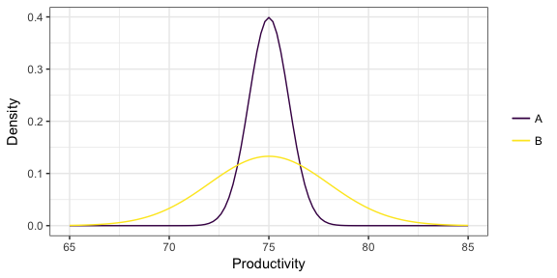

A:

Pros – The variance is much smaller than B;

The probability at productivity score 75 is extremely high.

Cons – The productivity score focuses in a small range, from 73 to 77.

B:

Pros – B can have higher productivity score than A;

Cons – The variance is very large, and the productivity score is not very stable.

2. Two “non-overlapping” forecasts

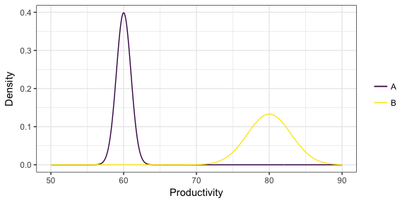

A:

Pros – The variance is much smaller than B;

The probability at productivity score 60 is extremely high;

The outcome is very predictable

Cons – The productivity score is low.

B:

Pros – B can have much higher productivity score than A;

The mean is 20 higher than the mean of A

Cons – The variance is larger, and the productivity score is not very stable.

3. You’ve formed a probabilist forecast for a particular value of the predictors, displayed below as a density. You then collect test data for that same value of the predictor, indicated as the points below the density. What is the problem with the probabilistic forecast?

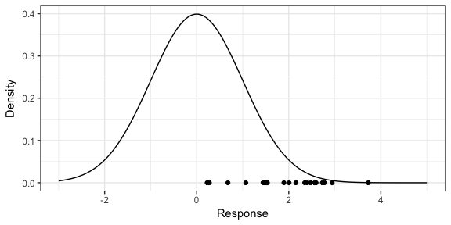

The probabilistic forecast has the mean at response = 0, but all the points are in the range of 0 to 4. The forecast is biased toward the left. The majority points fall in the range 2 to 3, so a good forecast would have the mean at similar values.